APPENDIX A
London Streetspace Programme (Harrow)
Low Traffic Neighbourhoods Review - November 2020

Introduction

We are making a real difference to our environment to encourage our residents to improve their health through active travel – all while reducing the chance of people catching Covid-19.
The Street spaces initiative will allow more space for people to safely walk or cycle in Harrow amid the coronavirus pandemic. Temporary cycle lanes and wider pavements and areas with reduced traffic flow are among the changes being made in many parts of the borough, thanks to Harrow Council working with TfL and Dft.
In May the Secretary of State for Transport issued statutory guidance under Section 18 of the Traffic Management Act 2004 to all highway authorities in England and the Secretary of State, Grant Shapps, describes the moment as:

“a once in a generation opportunity to deliver a lasting transformative change in how we make short journeys in our towns and cities. According to the National Travel Survey, in 2017-18 over 40% of urban journeys were under 2 miles – perfectly suited to walking and cycling.”

The guidance says that local authorities in areas with high levels of public transport use should take measures to reallocate road space to people walking and cycling to encourage active travel and enable social distancing due to the impact of social distancing on public transport capacity.

The Harrow Street Spaces programme took forward the government directive via Transport for London to deliver a range of active travel schemes including low traffic neighbourhoods. These schemes are implemented at locations where residential estates experience problems with through traffic creating environmental problems with road safety, pollution and nuisance.

The schemes consist of introducing modal filters to prevent through vehicular traffic using the residential estates as shortcuts in order to create safer conditions for pedestrians and cyclists and improve environmental conditions for residents. The Low Traffic Neighbourhoods have been implemented in 4 locations in the borough and the list of schemes is shown in the table below:

LTN-02 | Pinner View area, Headstone South
LTN-03 | Francis Road area, Greenhill
LTN-04 | Vaughan Road area, West Harrow
LTN-06 | Southfield Park area, North Harrow

Methodology

At the special meeting of TARSAP on 10th August it was recommended and subsequently agreed by the Deputy Leader on the 19th August that a review of the schemes would be conducted on a monthly basis to test the need for the measures to address the health crisis. The methodology to be used to assess the need for the schemes will take account of the following information:

- Pedestrian / cycling / vehicle activity (measured by counts)
- Emergency services comments
- Bus services comments (TfL)
- Officer observations regarding operational performance
- Public engagement

All of these factors will be reviewed, and a course of action recommended in this report.

The recommendation will be reviewed by the Portfolio Holder – Environment and Corporate Director – Community and the future of the schemes decided.

Current situation with the pandemic

The national position has shown a decrease in the number of infections reported daily from a high of 25,000 per day at the start of November to approximately 15,000 per day in late November which shows that the second wave of the virus is starting to recede as a consequence of the lockdown that commenced on 5th November.

In Harrow the incidence rate peaked in the period 16th – 22nd November and has started to show a slight decrease. In terms of the number of cases, there has been a reduction of about 60 cases per week across the borough. This is the impact of lockdown, but it must be noted that the rates are still very high and a return to social mixing will lead to a rapid rise in cases. The rate in older adults remains high and the testing rate has been increasing.

From 2nd December when lockdown ends the tiered system of restrictions will return. Councils in England have been placed on "medium", "high" or "very high'' alert with different levels of restrictions required. London is in the “high alert” tier 2 level.

Tier 2 restrictions include no mixing of households indoors, including pubs and restaurants, and the “rule of six” applies outdoors including private gardens and public spaces. Businesses and venues can continue to operate, in a COVID-Secure manner, pubs and bars must close, unless operating as restaurants. Hospitality venues can only serve alcohol with substantial meals, early closure (11pm) applies to most venues.

On 16th December London was put into the “very high” tier 3 alert level. The additional restrictions mean that the “rule of six” applies outdoors in some outdoor public places only, hospitality businesses, pubs, restaurants, hotels, entertainment venues must close travel is allowed for essential reasons only but must stay within tier 3 areas.

Pedestrian / cycling / vehicle activity (measured by counts)

Pedestrian and cycle activity counts and vehicle volume counts are being regularly undertaken at the sites. The pedestrian and cycle counts are taken at a mid-point in the scheme and repeat counts are undertaken at the same points for consistency. Both a weekday and weekend day are surveyed between 7am and 7pm to cover the busy periods. Surveys are undertaken by recording CCTV footage during the period of observation and later analysed by the survey company at their premises. Automatic traffic counters have also been used at each site to monitor traffic flows over the period of a week and calculate the average volume of daily vehicular traffic flow. The dates for data collection are as follows:

CCTV counts  - June 18th and 20th  - October 15th and 17th  - November 12th and 14th | Automatic traffic counters  - July 3rd – 9th  - October 12th – 18th

The surveys were undertaken at the following locations as follows:

- Victor Road by Harrow View  (LTN-02)  - Kingsfield Avenue / Pinner View (LTN-02)  - Pinner View by Canterbury Road (LTN-02)  - Pinner View by Bolton Road  (LTN-02)  - Gloucester Road by Station Road (LTN-02) | - Canterbury Road by Durham Road (LTN-02)  - Francis Road by Elmgrove Crescent (LTN-03)  - Vaughan Road by Bouverie Road (LTN-04)  - Blenheim Road by Bladon Gardens (LTN-04)  - Southfield Park by Pinner Road (LTN-06)
The table below gives details of all the pedestrian, cycle and vehicle counts undertaken at the points of closure. Vehicle counts are not done in the same locations after the roads are closed because vehicles are restricted. Alternative locations are used.

Weekday 7am - 7pm

Site  location | LTN-02 Pinner View area |  |  | LTN-03 Francis Road area |  |  | LTN-04 Vaughan Road area |  |  | LTN-06 Southfield Park
User type | Pedestrians | Cyclists | Vehicles | Pedestrians | Cyclists | Vehicles | Pedestrians | Cyclists | Vehicles | Pedestrians | Cyclists | Vehicles
July | 1975 | 356 | 6728 | 346 | 64 | 1113 | 1497 | 316 | 2547 | 480 | 52 | 2799
October | 3482 | 464 | N/A | 611 | 108 | N/A | 3536 | 338 | N/A | 956 | 72 | N/A
November | 4056 | 323 | N/A | 695 | 68 | N/A | 3451 | 229 | N/A | 1135 | 70 | N/A

Weekend 7am - 7pm

Site  location | LTN-02 Pinner View area |  |  | LTN-03 Francis Road area |  |  | LTN-04 Vaughan Road area |  |  | LTN-06 Southfield Park
User type | Pedestrians | Cyclists | Vehicles | Pedestrians | Cyclists | Vehicles | Pedestrians | Cyclists | Vehicles | Pedestrians | Cyclists | Vehicles
July | 2361 | 988 | 6274 | 293 | 120 | 972 | 1814 | 768 | 2297 | 529 | 164 | 2400
October | 2526 | 564 | N/A | 343 | 80 | N/A | 1859 | 334 | N/A | 450 | 88 | N/A
November | 1729 | 96 | N/A | 216 | 20 | N/A | 1237 | 82 | N/A | 343 | 11 | N/A

There are in excess of 10,000 vehicles per day that were using residential streets to make journeys which are now restricted. It is estimated that local journeys by residents with a destination or origin within the low traffic neighbourhoods accounts for only about 30% of that total.

The November surveys were undertaken during the second period of lockdown when non-essential journeys were restricted. The number of pedestrians has generally increased in the week but reduced at the weekend. The number cyclists have generally reduced during the week and more significantly at the weekend. This is clearly a consequence of the lockdown reducing the number of non-essential journeys.

Manor Way and Priory Way issues

The two streets parallel with Southfield Park (Manor Way and Priory Way) between Parkside Way and Headstone Lane have experienced some additional traffic as a consequence of the introduction of the low traffic neighbourhood because no measures had been introduced in these streets at the same time. The table below shows the vehicle flows recorded.

Site | Month | Weekday | Weekend
Southfield Park | July | 2799 | 2400
 | October | 780 | 653
 | November | 655 | 481
Priory Way | July | 1507 | 1359
 | October | 1864 | 1208
 | November | 1561 | 872
Manor Way | July | 701 | 580
 | October | 1324 | 953
 | November | 1140 | 658

This indicates that in October during the week vehicle flows had increased in Priory Way by 24% and in Manor Way by 88% and by a lesser amount at the weekend. In November the level of traffic has reduced as a consequence of the second lockdown reducing non-essential journeys.

The Council has received a large volume of correspondence from residents of Manor Way and Priory Way about the increase in vehicles using their roads which is negatively affecting them. Whilst the actual vehicular flows are still relatively small, they have a disproportionate impact due to the level of on-street parking and narrow width of the roads. There is therefore a need to mitigate this by introducing some measures to restrict this traffic which will be considered as apart of reviewing alternative measures for the LTNs.

In addition both Manor Way and Priory Way had already been identified for road safety measures prior to the pandemic and now that TfL have provided funding for the Council’s Local Implementation Programme in the second half of 2020/21 proposals for traffic calming in these roads is being taken forward. These proposals can help to address problems with speeding traffic and associated road safety issues. Any proposals will also be subject to public consultation in the near future.

At the time of writing this report roadworks undertaken by Cadent Gas on Station Road / Parkside Way in the middle of November did cause a significant level of congestion on this road corridor affecting many roads in the area and as a consequence a decision was taken to temporarily remove the closure in Southfield Park on 23rd November (see appendix 1). This has relieved any excess delay and congestion on the road network at the current time until the review of alternative LTN measures is concluded.

Queue length surveys

As a consequence of introducing the low traffic neighbourhoods some displacement of through journeys onto main roads was anticipated.

The plan below shows junctions on the main road network in close proximity to the low traffic neighbourhoods that are being monitored to assess any potential impact. Queue length surveys have been undertaken in order to assess any changes in congestion and delay.

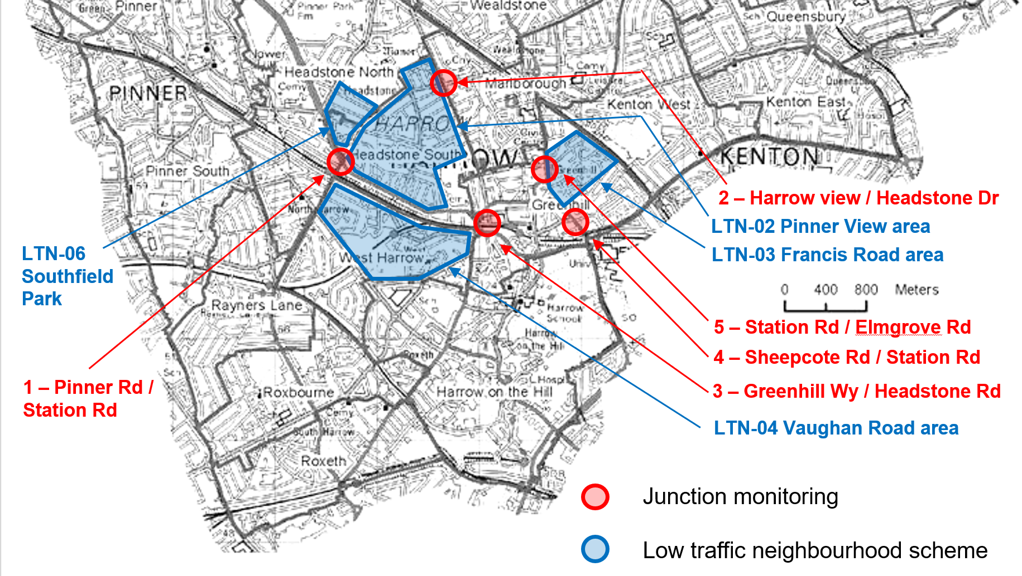

The dates for data collection are as follows:
CCTV counts
- July 23rd and 25th and August 13th and 15th
- October 15th and 17th
- November 12th and 14th

The surveys were undertaken at the following locations as follows:
- A404 Pinner Road / Station Road
- Headstone Drive / Harrow View / Headstone Gardens
- Greenhill Way / Headstone Road
- A409 Sheepcote Road / Station Road
- A409 Station Road / Elmgrove Road / Hindes Road

The table below gives details of the surveys.

Junction | Month |  | Weekday |  |  | Weekend
Maximum queue lengths (all vehicles / all arms) |  | AM | Inter peak | PM | AM | Inter peak | PM
1 - A404 Pinner Road / Station Road | July | 84 | 120 | 45 | 66 | 148 | 116
 | October | 178 | 163 | 198 | 84 | 198 | 181
 | November | 195 | 163 | 145 | 58 | 158 | 150
2 - Headstone Drive / Harrow View / Headstone Gardens | July | 97 | 132 | 175 | 99 | 129 | 152
 | October | 202 | 162 | 200 | 127 | 172 | 165
 | November | 174 | 114 | 186 | 59 | 123 | 133
3 - Greenhill Way / Headstone Road | August | 87 | 100 | 139 | 60 | 120 | 113
 | October | 99 | 108 | 126 | 85 | 107 | 129
 | November | 125 | 105 | 140 | 87 | 160 | 160
4 - A409 Sheepcote Road / Station Road | July | 43 | 56 | 69 | 29 | 57 | 53
 | October | 69 | 57 | 68 | 42 | 70 | 71
 | November | 61 | 54 | 63 | 25 | 56 | 56
5 - A409 Station Road / Elmgrove Road / Hindes Road | July | 96 | 93 | 126 | 63 | 98 | 111
 | October | 105 | 76 | 120 | 73 | 95 | 95
 | November | 141 | 105 | 129 | 58 | 113 | 105

The queue lengths recorded in July and August are marginally lower than prior to the start of the pandemic. The November surveys are variable and show changing traffic patterns as a consequence of the second lockdown and roadworks on the network. During the week increased delays can be seen at sites 1, 3 and 5 in the AM peak whilst there is less congestion at sites 2 and 4. Delays were generally reduced at the weekend except for sites 3 and 5 in the inter peak and PM peak periods.

Emergency services comments

The Metropolitan Police, Fire & Rescue Service and Ambulance service have been contacted to seek their views about the impact of the low traffic neighbourhood schemes on their respective services.

The Fire Service are reviewing the impact of the schemes carefully which are in close proximity to Harrow Fire Station located in Pinner Road. Whilst attendance times are currently within the statutory requirements (6 minutes), due to the proximity of the station, any future increase in delays could affect call outs generally. Currently there are no significant issues.

No specific comments about the schemes have been received from the Metropolitan Police but generic advice has been provided.

A meeting was organised by Harrow with the London Ambulance Service (LAS) on 15th December regarding the LTN schemes to check on any impact of the schemes because no comments had been received beforehand. The LAS confirmed that their reporting of any incidents has been low in recent months but has now improved due to a review of the crews operating processes. They are experiencing some problems with the fixed closures because crews attend incidents from wherever resources are available and so the crews may not have local knowledge of the area. In addition, their use of satnav systems is limited by their available technology. It was agreed that the use of virtual closures with CCTV enforcement is preferred as LAS crews would be exempt from these. This has worked well in other parts of London.

TfL bus services comments

Transport for London oversee the commissioning and operation of bus services in London and they have been contacted to seek their views about the impact of the low traffic neighbourhood schemes on bus services.

TfL have noted that traffic levels are still generally lower than prior to the pandemic and their bus operators are not experiencing any negative impacts on bus journey times in the area.

Officer observations regarding operational performance

Officers have undertaken on-site observations periodically to check on the operation of the schemes.

Incidents where vehicles have tried to bypass the points of closure by driving on the footway have now ceased because physical measures have been taken to stop such behaviour.

Issues with vehicles getting caught out by the restrictions have become less of a problem since additional signing has been implemented to highlight the points of closures and restricted access to residential estates. There are less instances of motorists being unaware of the restrictions.

The increase in pedestrian movement in the areas is noticeable particularly at school journey times.

The introduction of a lockdown from the 5th November with restrictions on all non-essential travel has initially reduced pressures on the road network from congestion and delay.

However, at the time of preparing this report roadworks were being undertaken by Cadent Gas at the junction of Parkside Way and Southfield Park with temporary traffic management measures using 4-way traffic signals. This had caused a significant amount of congestion and delay on the main road network and adversely affected local residents and as a consequence road closures within the LTNs were temporarily opened up from 23rd November to relieve the level of congestion. Closures were removed at Southfield Park, Kingsfield Avenue and Pinner Way (by Bolton Road). This is shown in Appendix 1.

This action was intended as a temporary measure, however, given the current situation with reviewing the LTNs any decision to put back the closures may be held until communications and engagement with the local communities has been undertaken.

Public engagement

An engagement portal was setup at the beginning of October to facilitate the receipt of public comments for all of the on-going streetspace schemes trials. A summary of the feedback for low traffic neighbourhood schemes in October can be seen in the table below.

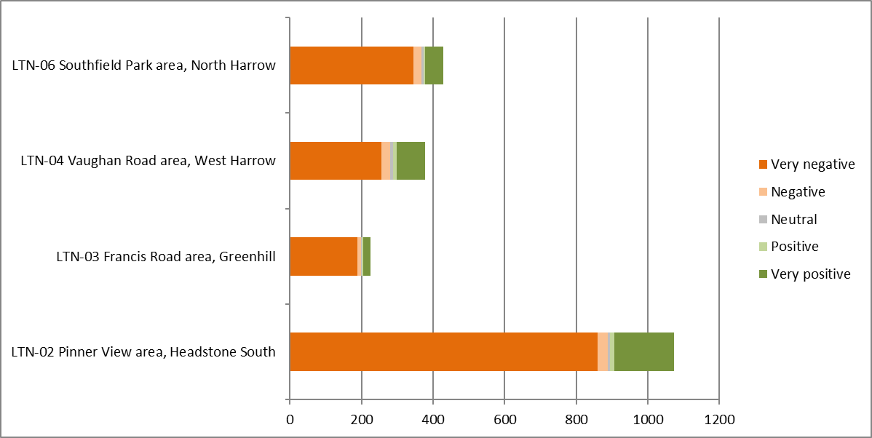

The engagement feedback indicates a continuing level of unpopularity amongst the community towards these schemes. A more detailed analysis of the free comments received highlighted the following common issues:

- The measures were considered more positive by cyclists although they represent a smaller proportion of the responses received (7%).
- The largest groups of responses were from residents (70%) and motorists (23%) and a larger proportion of these groups expressed more negative sentiments.
- Many views indicated that there is increased congestion and queuing at busy times on the main road network.
- Many views indicated that the restricted access to residential estates is inconvenient and increases journey times.
- A proportion of residents clearly support the measures and the benefits for public health, active travel, road safety and for children.
- Some comments concerning the removal of road closures were variable with some people supportive and other critical of the decision.
- There were many generally derogatory comments that were not substantiated with any reasons.

Most comments are a reaction to changes that affect lifestyles that rely heavily on using the private car and it is expected that making changes is something that will happen over a longer period of time. This is the experience of other London boroughs that have introduced similar schemes. The initial reaction to the schemes is understandably more negative as a consequence.

Options

Detailed below are the options for consideration:

- That the concerns about the scheme by local residents, levels of congestion and delay on the main road network and temporary action to remove some road closures be noted.

- That proposals for traffic calming in Manor Way and Priory Way as a part of the LIP programme are noted.

- The next review of the schemes is undertaken before the end of December.

Decision:
To be determined.
APPENDIX 1 – TEMPORARY REMOVAL OF CLOSURES (23rd November 2020)

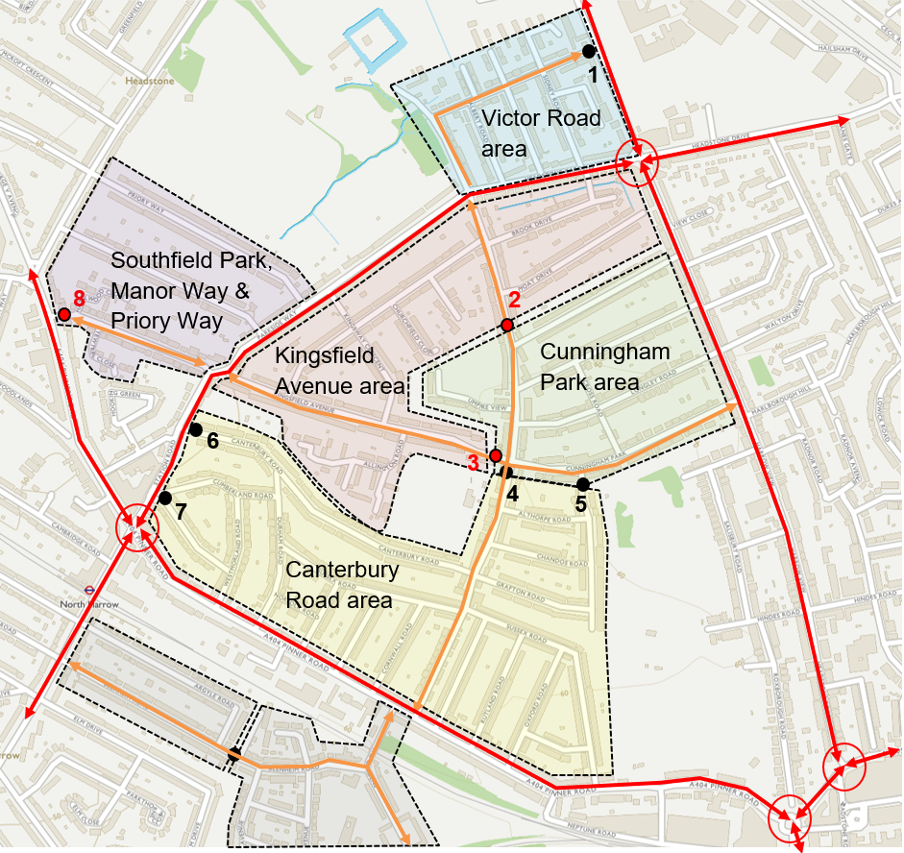

Red lines (solid) – Main road network
Orange lines (solid) – short cuts on residential streets before LTN introduced
Black dots – closures (planters)
Red dots – closures (planters) temporarily removed to ease network congestion

